University of Utah
School of Computing
CS 6967: Security Operations

Name: Syeda Mishra Saiara
uID: u1457424

Lab 9 Response Outline

Lab 9: Basic Threat Hunting on Windows
Test 1: Add Windows Into the LAN
Summary of test experience:
This lab is about threat hunting on a windows system in our existing LAN. To progress at first I downloaded the ISO image of a Windows 10 education version and imported it into the virtualbox. After that, I configured the network of the windows VM. After completing the installation and starting the VM, I checked from the powershell as an admin to double check if the VM is within the LAN.
Screenshot of test results:
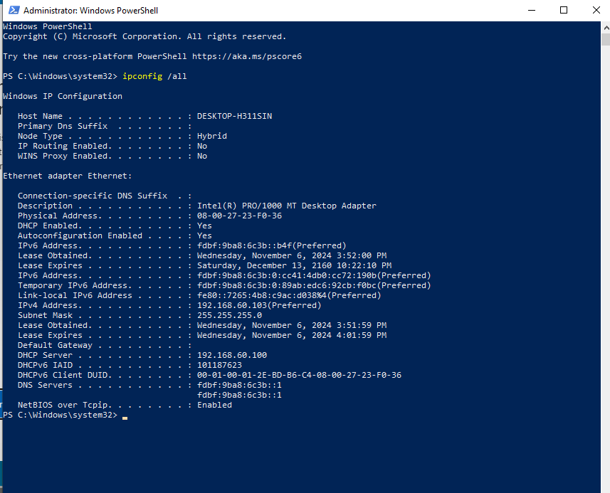
How does the image demonstrate that you completed the test?
After running ipconfig /all within the powershell, it had an IPv4 address of 192.168.60.103, which means the windows VM is within the LAN, since the domain IP of my LAN is also 192.168.60.*/24.

Test 2: Connect Windows VM to the Internet
Summary of test experience:
The next step was to connect the VM to the internet. As instructed in the manual, I connected the ethernet connection and added the IP of my router, 192.168.60.10 as the default gateway. As a test I pinged 8.8.8.8 to see if the windows VM was connected to the internet.
Screenshot of test results:
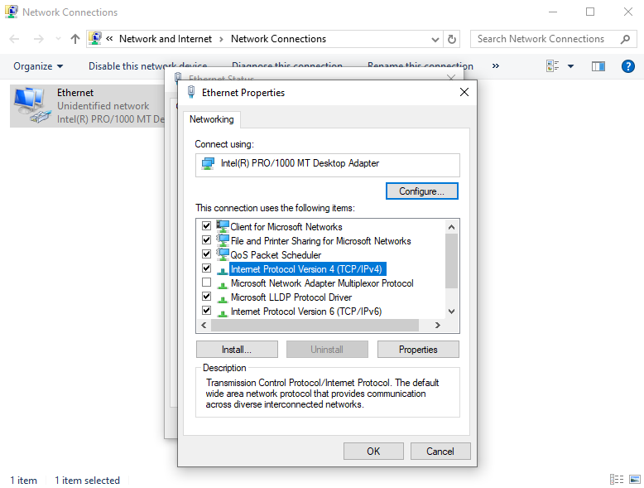
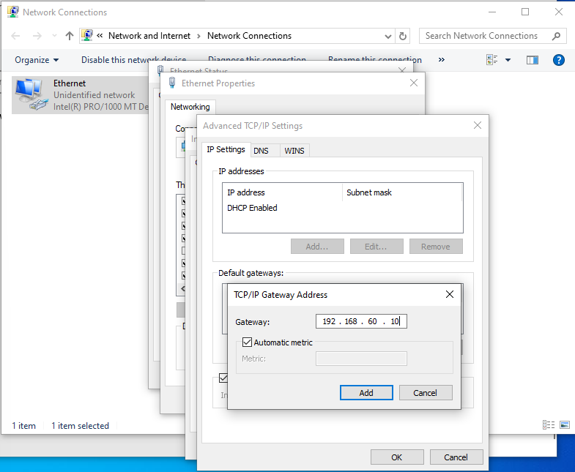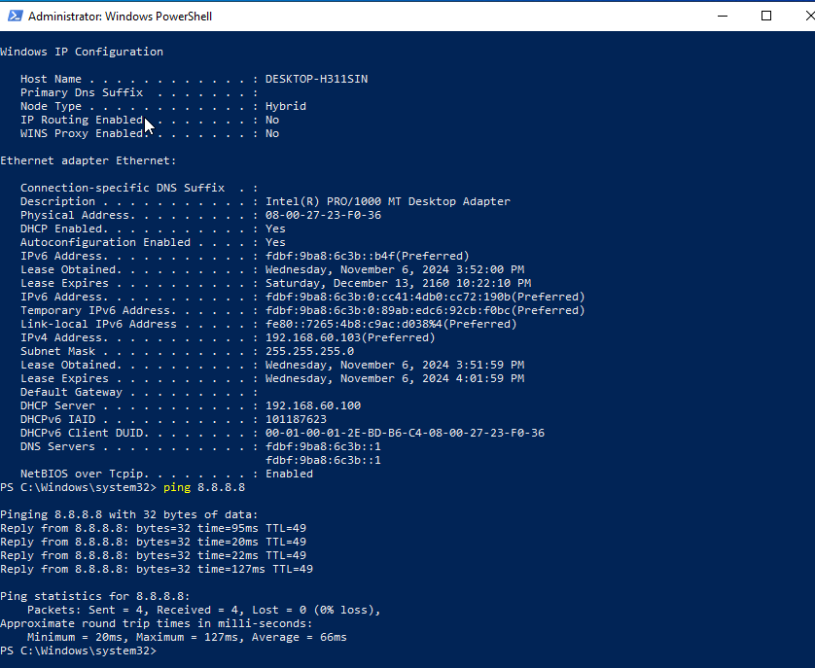

How does the image demonstrate that you completed the test?
After pinging through the VM powershell, there were statistics about the packets sent, received, and lost and time and bytes. These results show that the VM was able to connect to the internet.

Test 3: Test the Audit Setup
Summary of test experience:
This particular test was difficult for me, as I had to reconfigure a lot many times because of an error of the container not being accessible, even though the owner and privileges were changed to admin. Later I resolved it by ensuring the policy to the child folders and containers too. Apart from that, I made changes to the policy as instructed in the manual and blog.
Screenshot of test results:
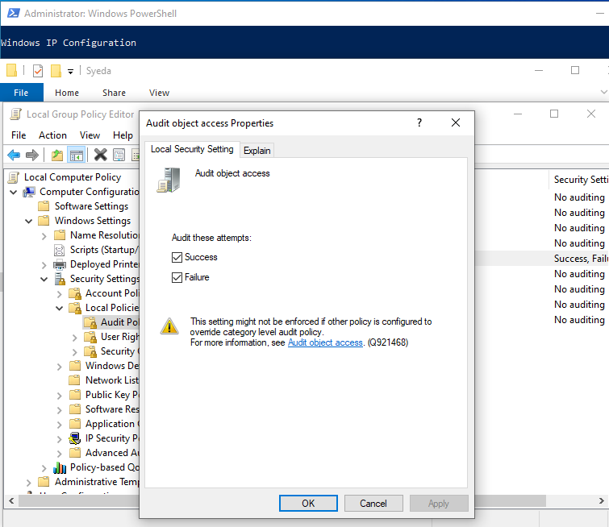
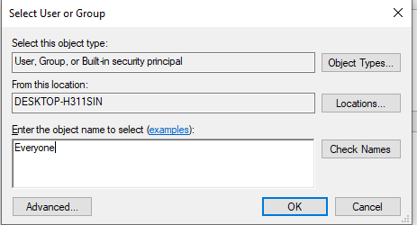

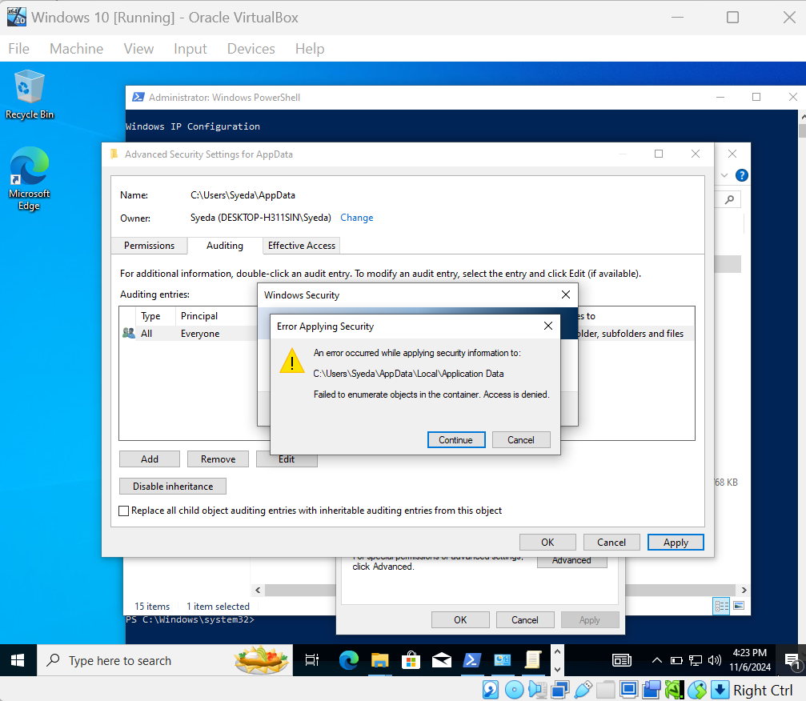
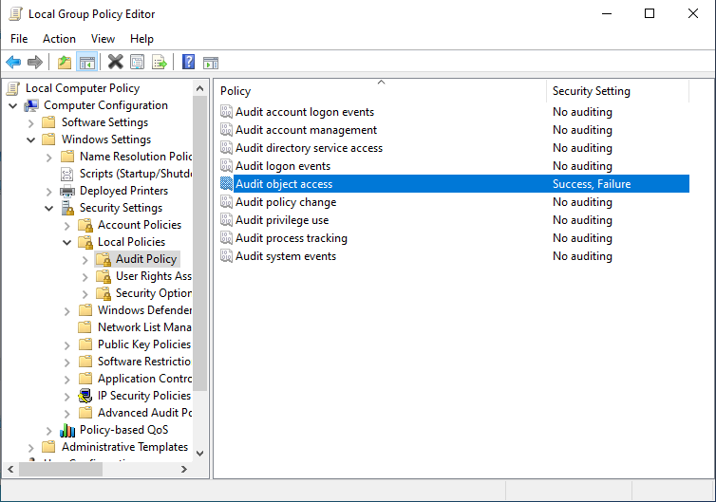
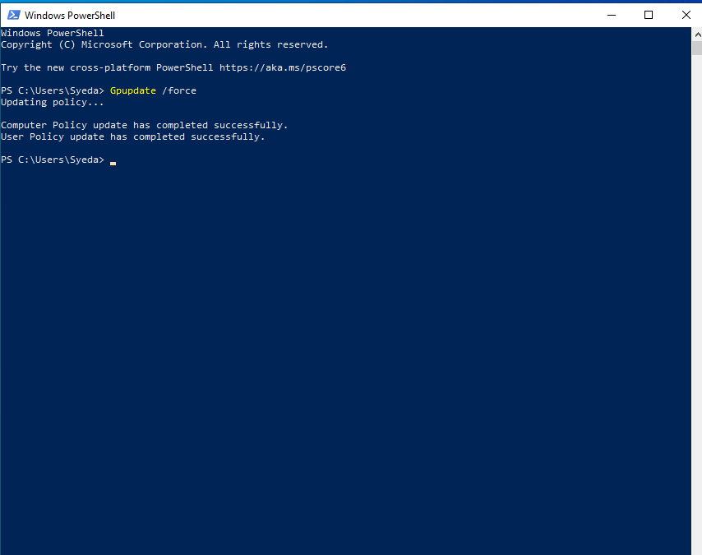
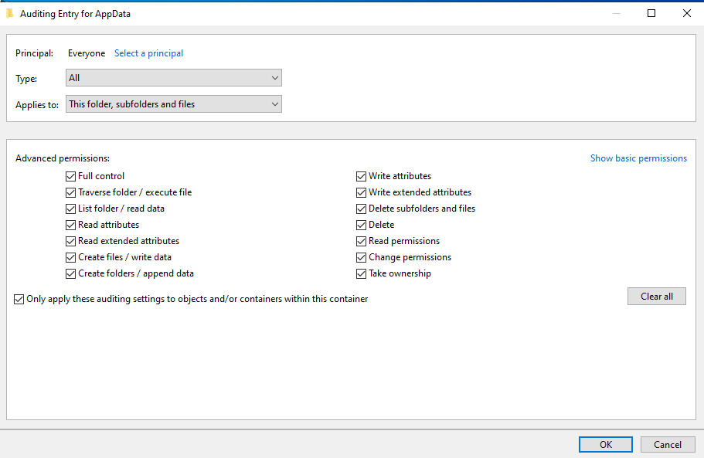
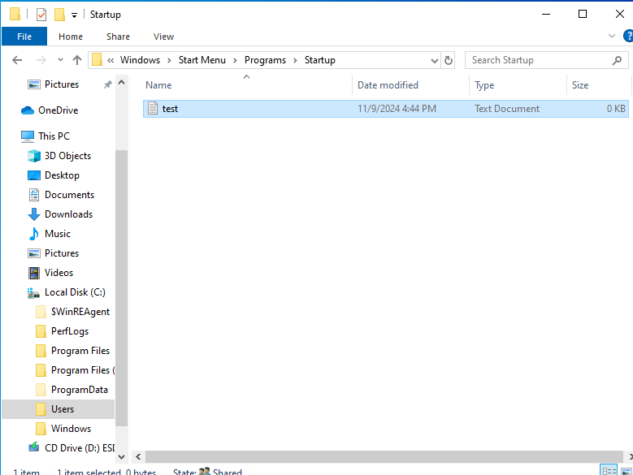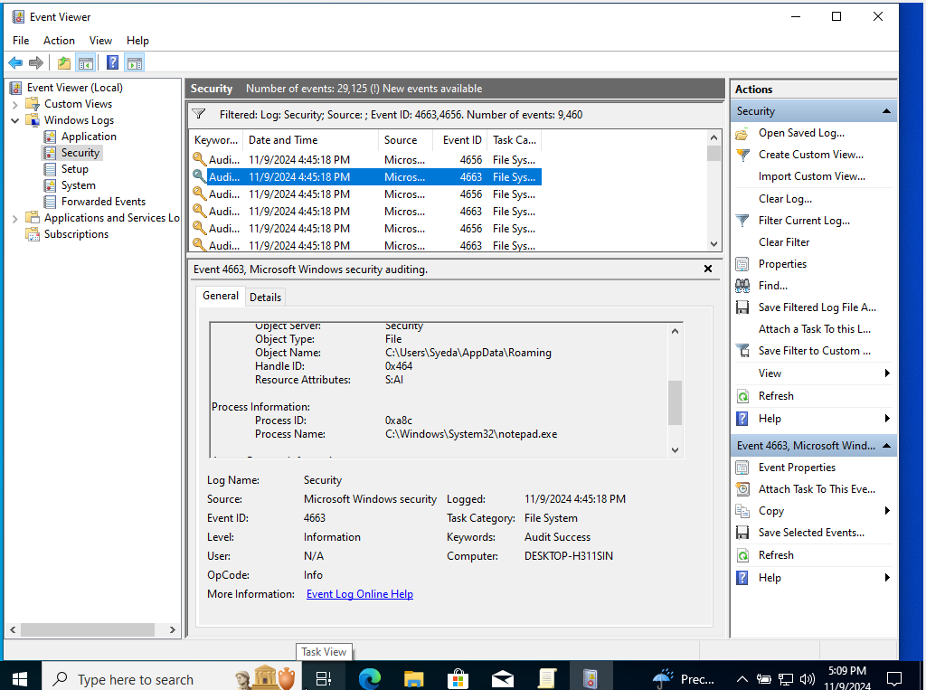

How does the image demonstrate that you completed the test?
The last screenshot demonstrates the audit of the test.txt file being added and modified in that specific directory.

Test 4: Test SSH Service
Summary of test experience:
Now that the auditing policies were changed, it was time to ssh the windows VM, because later part it is tasked to install malware and the devices used for SSHing the windows VM will be used for auditing threats. For SSHing to the VM, it is first required to install an SSH client and server in windows. After that, the ssh rules and firewall rules were configured from the powershell as instructed. Then I ran the command ssh -p 22 syeda@192.168.60.103 from both my kali linux and webgoat VMs. I was able to successfully SSH into the windows VM.
Screenshot of test results:
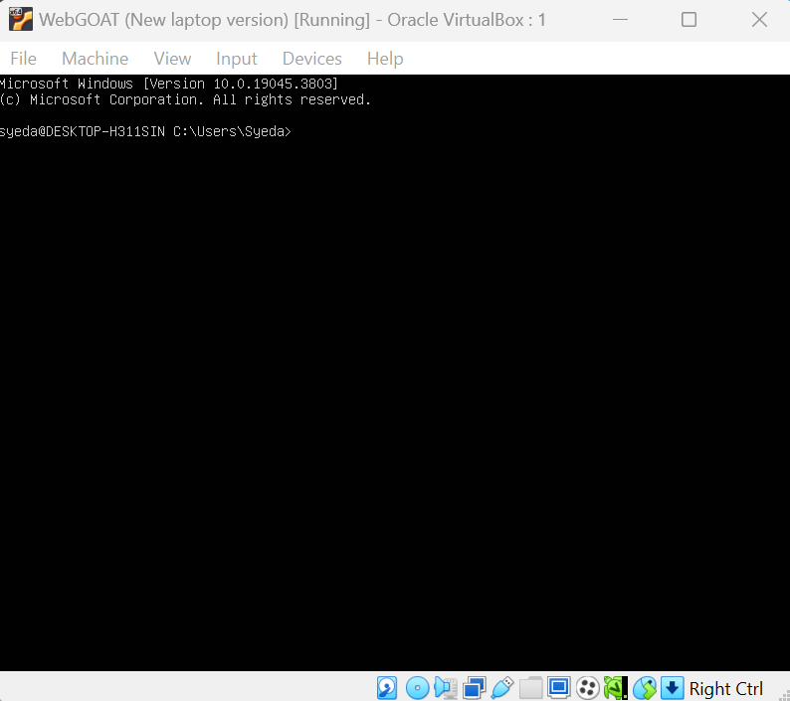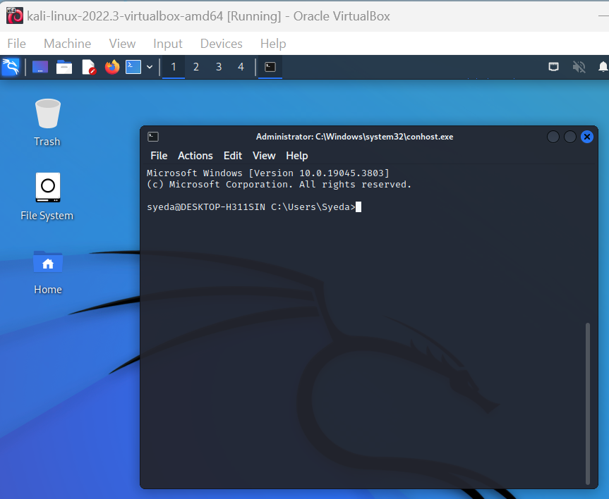

How does the image demonstrate that you completed the test?
The screenshots show that the terminals of both Kali Linux and Webgoat server were able to SSH into the windows VM, and were able to access via terminals.

Test 5: Test Whether Malware Infects Windows VM
Summary of test experience:
At first I took a snapshot of the clean windows. After unzipping the downloaded malware file, I ran that on my windows system and it successfully took control over the windows system.
Screenshot of test results:
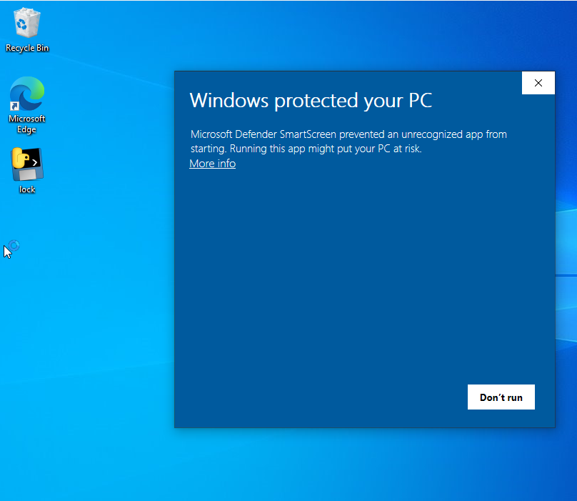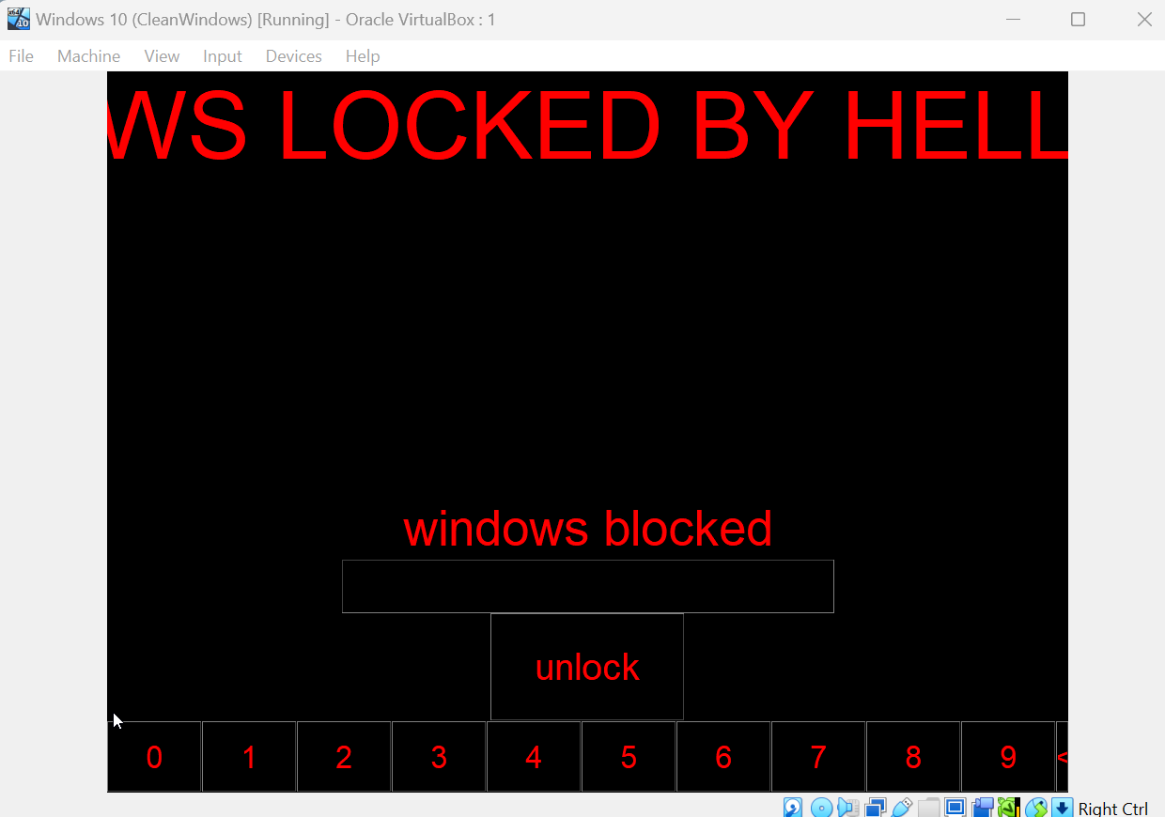
How does the image demonstrate that you completed the test?
The last screenshot shows the taking over of the malware in the Windows system.

Test 6: Find Malicious Processes
Summary of test experience:
The next step was to find the malicious process by auditing through one of the devices that SSHed into the windows system. I ran the command tasklist from my kali Linux SSH’d into windows. Then I found the lock.exe process ID.
Screenshot of test results:
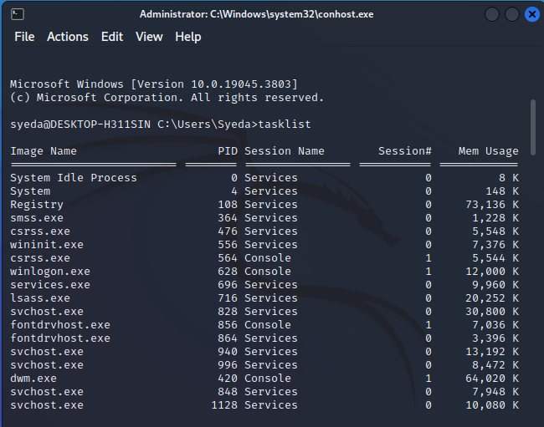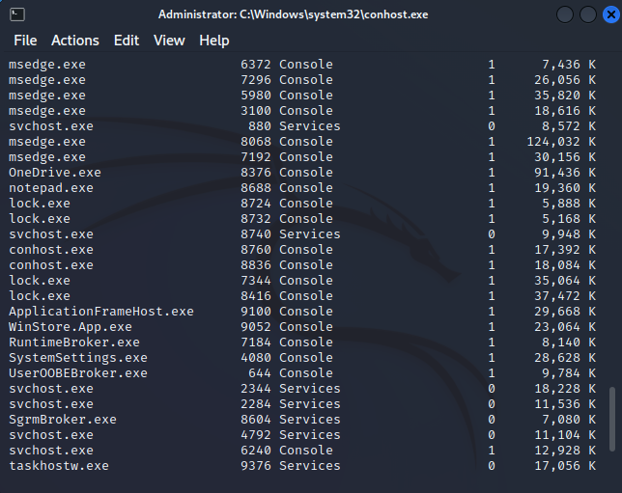
How does the image demonstrate that you completed the test?
lock.exe was running within the process ID 8724, 8732, 7344, and 8416 according to the results shown in tasklist.

Test 7: Kill the Malicious Processes
Summary of test experience:
The goal of this test was to kill the malicious process that was running in the windows system by the command taskkill /IM lock.exe /F
Screenshot of test results:
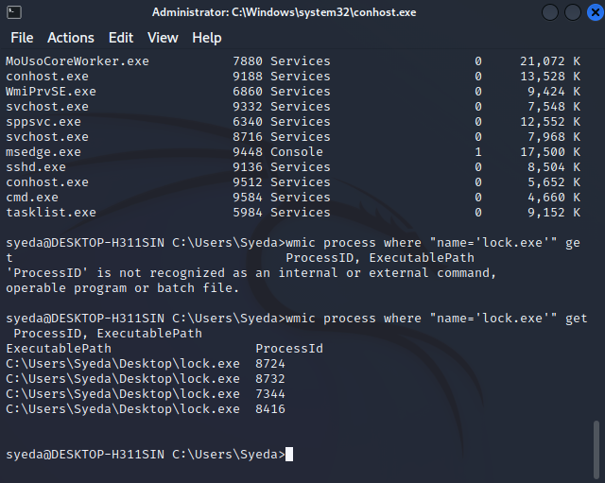
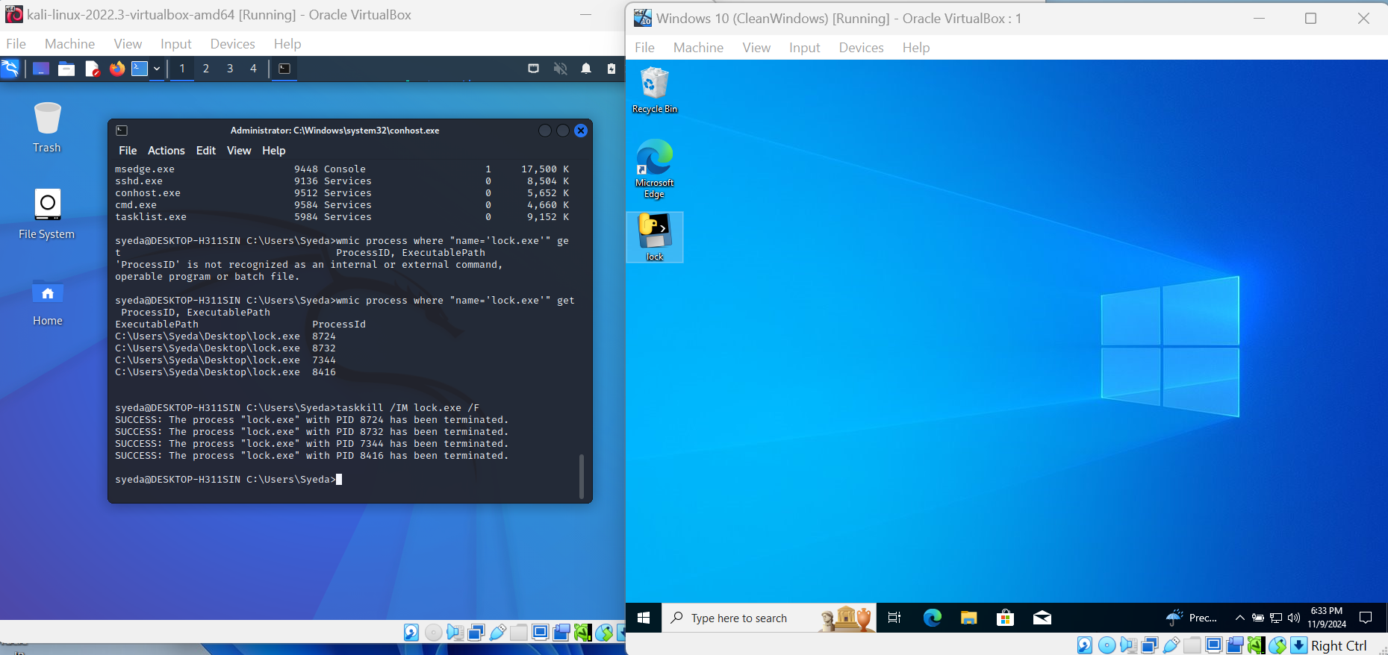
How does the image demonstrate that you completed the test?
After killing the processes, the windows system was restored again. And the clean snapshot version was restored.
Test 8: Clean Up Changes
Summary of test experience:
The goal of this test was to clean up the messes and auditing to see where the changes were made. I reviewed the processes through the event viewer once I regained access to the windows VM.
Screenshot of test results:
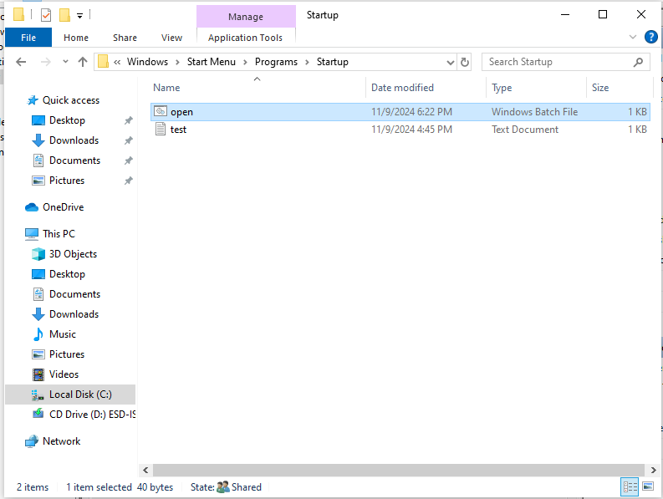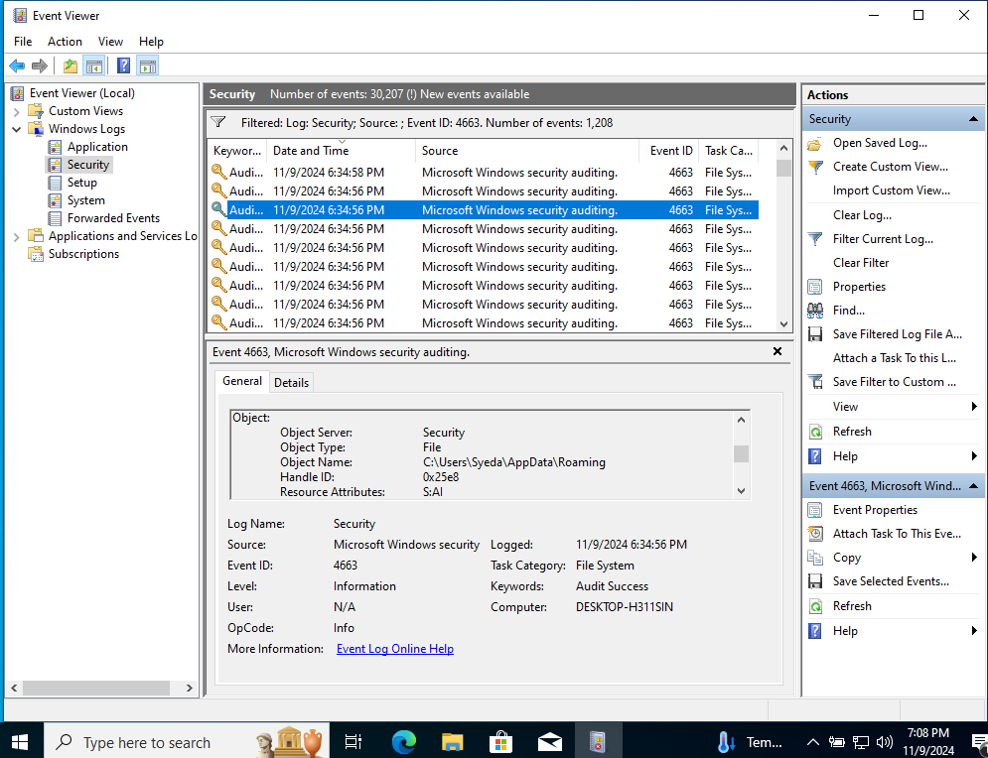
How does the image demonstrate that you completed the test?
The auditing proves that, the malware left a file open.bat in the system when it started to run in the system.

